**Project Design Phase-II**

**Data Flow Diagram & User Stories**

|  |  |
| --- | --- |
| Date | 01 July 2025 |
| Team ID | LTVIP2025TMID40229 |
| Project Name | Hematovision |
| Maximum Marks | 4 Marks |

**Data Flow Diagrams:**

A Data Flow Diagram (DFD) is a traditional visual representation of the information flows within a system. A neat and clear DFD can depict the right amount of the system requirement graphically. It shows how data enters and leaves the system, what changes the information, and where data is stored.

Hematovision : DFD model

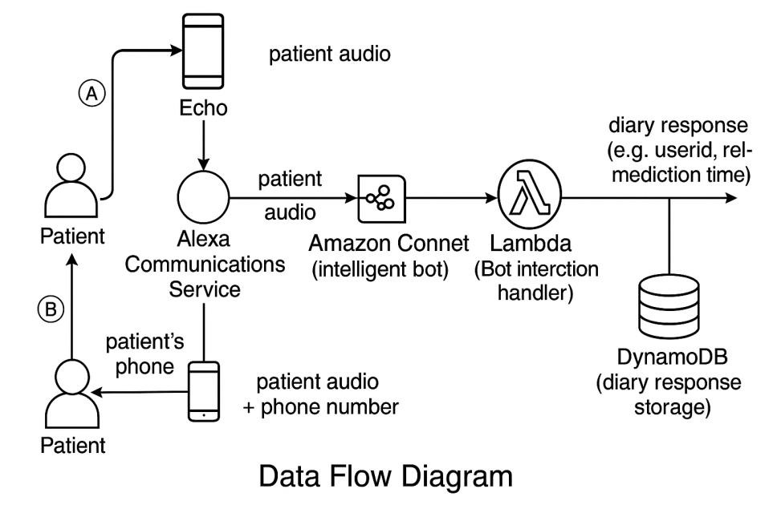

**User Stories**

|  |  |  |  |  |  |  |
| --- | --- | --- | --- | --- | --- | --- |
| **Sprint** | **Functional**  **Requirement (Epic)** | **User Story**  **Number** | **User Story / Task** | **Story Points** | **Priority** | **Team**  **Members** |
| Sprint-1 | Registration | USN-1 | As a user, I can register for the application by entering my email, password, and confirming my password. | 2 | High | Goda  Srinivasulu  Reddy |
| Sprint-1 |  | USN-2 | As a user, I will receive confirmation email once I have registered for the application | 1 | High | Goda  Srinivasulu  Reddy |
| Sprint-2 |  | USN-3 | As a user, I can register for the application through Facebook | 2 | Low | Dudiki Naga  Sowmya |
| Sprint-1 |  | USN-4 | As a user, I can register for the application through Gmail | 2 | Medium | Goda  Srinivasulu  Reddy |
| Sprint-1 | Login | USN-5 | As a user, I can log into the application by entering email & password | 1 | High | Goda  Srinivasulu  Reddy |
| Sprint -3 | Dashboard | USN-6 | As a user, Register in github | 2 | Medium | Gopu  Radhika |
| Sprint -4 |  | USN-7 | As a user, Distributed project as tasks | 1 | Low | Devarapalli Ashok |
| Sprint -2 |  | USN-8 | As a user, completed what I have the task | 2 | Medium | Dudiki Naga  Sowmya |
| Sprint -3 | Word | USN-9 | As a user, completed the documentation as per the templates. | 3 | High | Gopu  Radhika |